Question 4 (28 marks)
Askinoise Chocolate (AC) is a privately owned small batch chocolate manufacturer, located in Picton, Ontario. In 2005, the company was founded by Shawn Askinoise, who left a successful career as a criminal defense lawyer to start his own business.
There are two key elements to ACs success. First, the business model hinges on being a good neighbor and citizen. AC is committed to creating a program they call 'direct trade,' in which they source their chocolate beans directly from small farmers in the four growing regions - Tanzania; Ecuador; Philippines; and Honduras. Shawn has developed personal trusted relationships with each of these farmers. Since 2006 he has made over 40 personal trips visiting farmers in these regions. The ‘direct trade’ program is beneficial for the farmers because they get to keep most of the money rather than paying middlemen in the supply chain and AC pays more than Fair Trade prices. (Fair trade is the minimum prices set by Fair Trade International that importers will pay agriculture producers in developing countries.) In many cases, AC wires the money directly into bank accounts they helped the farmers set up. AC has profit sharing agreements with each of the farmers whereby each farmer is entitled to a percentage of the gross margin. During Shawn’s annual visits to the farmers he shares AC financial statements and uses the financial statements to demonstrate how AC reached a profit using their beans and explains how they can influence that profit through superior farming methods.
The second element of AC’s success is the way it is made - in small batches and in-house. The process, which involves over 70 steps – many of which are manual intensive, requires extensive investment in equipment. One piece of equipment is an artisanal piece that is over 70 years old. The equipment loan, which was secured in 2005 by Shawn’s personal guarantee, was completely paid off in 2015. The equipment is now 10 years old and many pieces, including the artisanal piece require extensive maintenance, other pieces require replacement. With the growth in sales, AC also needs new equipment to expand production capacity. Shawn plans on securing an additional loan in 2016.
“Harris and Harris LLP”, a small two partner accounting firm with approximately 15 employees, is also located in Picton, Ontario. The two partners are brothers and Tom Harris, one of brothers has provided Shawn with tax and advisory services since Shawn’s days as lawyer – over 25 years ago. At the time, Tom’s and Shawn’s kids were friends and they would see each other at soccer matches. Eventually Tom became both Shawn’s friend and business advisor.
Over the years Tom has advised Shawn to use open-book management to run his business. Shawn holds monthly employee meetings with all 25 employees and reviews the financial statements, current sales levels and production issues. AC awards all employees an annual bonus based on a percentage of net income.
Recently Tom and Shawn met and Shawn asked if Harris and Harris could perform an audit of AC’s financial statements for the year ended December 31, 2015. He thought the business had grown large enough to obtain a loan for the needed equipment without requiring his personal guarantee; however, the bank would only provide a loan for the equipment if it was secured by receivables and the equipment and the AC provides annual audited financial statements. Shawn thought that the audit opinion would also add credibility to the statements when he presents them to his cocoa bean farmers. He mentioned that every year he translates the financial statements to Spanish, Swahili and Filipino, the growers’ local languages. He wondered if the audit opinion could also be translated in these languages.
It is now February 2016, you are a senior auditor at Harris and Harris. Tom recently sent you an email asking you to document the initial engagement acceptance matters and preliminary audit planning issues. In the email Tom also wrote: “I realize that all audit staff, including you are fully booked on other engagements but we need to find some time during this busy season to complete this audit - after all, Shawn is a long-time client and quality client service is a key part of our mission.” Below is a summary of the notes he had taken and financial information he collected during his February 1st meeting with Shawn.
- All accounting functions are performed by Kristen Clements. She joined the company in 2010 as the controller after completing a diploma in accounting at the local college. AC uses AccPac, an off the shelf accounting system which hasn’t been updated since it was purchased. Employees have been resistant to an upgrade since the cost would reduce the company’s profit.
- Kristen is responsible for all accounting cycles. For instance, for the revenue cycle: she prepares and mails invoices, records receivables and cash receipts, opens mail and delivers deposits to bank. She is also responsible for collections and sends notices to customers that have not paid, she determines the allowance for doubtful accounts based on the accounts receivable age.
- Cocoa beans are shipped with FOB shipping point (title transfers at shipping point) and they are payable within 30 days of shipment. Purchase orders are prepared by Shawn and forwarded to Kristen. Upon receipt of the goods, Carmen the receiver, completes the receiving documents. Carmen forwards the bill of lading and the receiving document to Kristen. When Kristen receives the invoice she records the payable and prepares the cheque for signing. She then delivers the cheques and supporting documents to Shawn for signing. AC is often late making a payment because the shipment may take up to a month to arrive.

- Shawn and Kristen both have signing authority on the chequing account. Shawn reviews the supporting documentation prior to signing of cheques. He signs almost all company cheques except when he is away travelling to the farmers. These visits can be time consuming and often keep him away from the office for weeks at a time. In his absence Kristen assumes the cheque signing responsibility.
- Wire transfers to pay the farmers are made by way of an on-line banking system, which requires a password. Only Shawn and Kristen are privy to the user i.d. and password for wire transfers. For supplier payments, Shawn reviews and approves the supporting documentation (purchase order, receiving documents and invoice) and initials the invoice. Kristen then completes the online wire transfer.
- Kristen prepares monthly financial statements, which are reviewed and discussed at the monthly employee meetings. She also prepares and files a monthly bank reconciliation.
- AC customers include major retailers such as Target, Marshalls and high end grocery stores. One month before Christmas, a major selling time – representing approximately 30% of sales, AC’s custom-made cocoa butter press broke down. It took two weeks to obtain the necessary part to repair the machine. Orders were shipped to major retailers over two weeks late and several are refusing to pay for the order claiming that the delayed delivery resulted in significant quantity of unsold chocolate.
- Several other pieces of equipment required repair throughout the year. Kristen capitalized the costs of all parts purchased.
- The AC sales team, comprised of 3 associates, began attending many trade, wedding and food shows in the current year. Kristen capitalized these costs since they would generate sales in the future.

The following is selected financial information for AC: 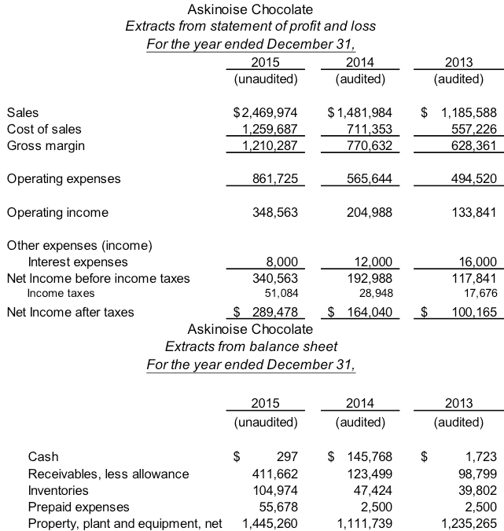

Required:
- Identify and explain four client acceptance considerations (4 marks)
- Assuming you recommend accepting the client, what would you set acceptable audit risk – high, medium, low. Provide your rationale (5 marks)
- Determine planning materiality, and performance materiality (Ensure to explain the rationale and support your analysis with calculations). (7 marks )
- Identify three account balances, which have a high risk of material misstatement. Include in your discussion, an analysis of inherent and control risk as well as an explanation of how the account would be overstated or understated and the relevant assertions Arrange your answer in the table below.(12 marks)
Affected Account(s) 3 marks | Explanation – inherent risk & control risk (using case facts) 3 marks) | Nature of the Misstatement( over/understatement and Affected Assertion(s) (total 6 marks)

